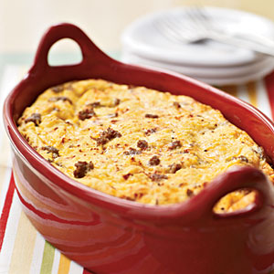
Photo: Randy Mayor; Styling: Leigh Ann Ross

Prep this the night before for an easy breakfast or brunch. Find turkey sausage in the freezer section of the supermarket with other breakfast meats.

Ingredients
Top of Form

Bottom of Form

- Cooking spray $

- 12 ounces turkey breakfast sausage $

- 2 cups 1% low-fat milk $

- 2 cups egg substitute $

- 1 teaspoon dry mustard
- 3/4 teaspoon salt $

- 1/2 teaspoon freshly ground black pepper
- 1/4 teaspoon ground red pepper
- 3 large eggs

- 16 (1-ounce) slices white bread

- 1 cup (4 ounces) finely shredded reduced-fat extra sharp cheddar cheese

- 1/4 teaspoon paprika

Preparation
- 1. Heat a large nonstick skillet over medium-high heat. Coat pan with cooking spray. Add sausage to pan; cook 5 minutes or until browned, stirring and breaking sausage to crumble. Remove from heat; cool.
- 2. Combine milk and next 6 ingredients (through eggs) in a large bowl, stirring with a whisk.
- 3. Trim crusts from bread. Cut bread into 1-inch cubes. Add bread cubes, sausage, and cheddar cheese to milk mixture, stirring to combine. Pour bread mixture into a 13 x 9–inch baking or 3-quart casserole dish coated with cooking spray, spreading egg mixture evenly in baking dish. Cover and refrigerate 8 hours or overnight.
- 4. Preheat oven to 350°.
- 5. Remove casserole from refrigerator; let stand 30 minutes. Sprinkle casserole evenly with paprika. Bake at 350° for 45 minutes or until set and lightly browned. Let stand 10 minutes.
Yield: 12 servings (serving size: about 1 cup)

Nutritional Information
Amount per serving
- Calories: 184
- Calories from fat: 33%
- Fat: 6.8g
- Saturated fat: 3.2g
- Monounsaturated fat: 1.5g
- Polyunsaturated fat: 0.8g
- Protein: 15.9g
- Carbohydrate: 14g
- Fiber: 0.6g
- Cholesterol: 76mg
- Iron: 2.2mg
- Sodium: 636mg
- Calcium: 181mg
Nutrition Guidelines for Healthy Living

